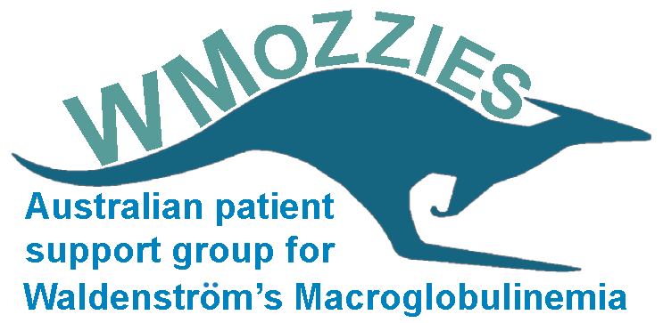

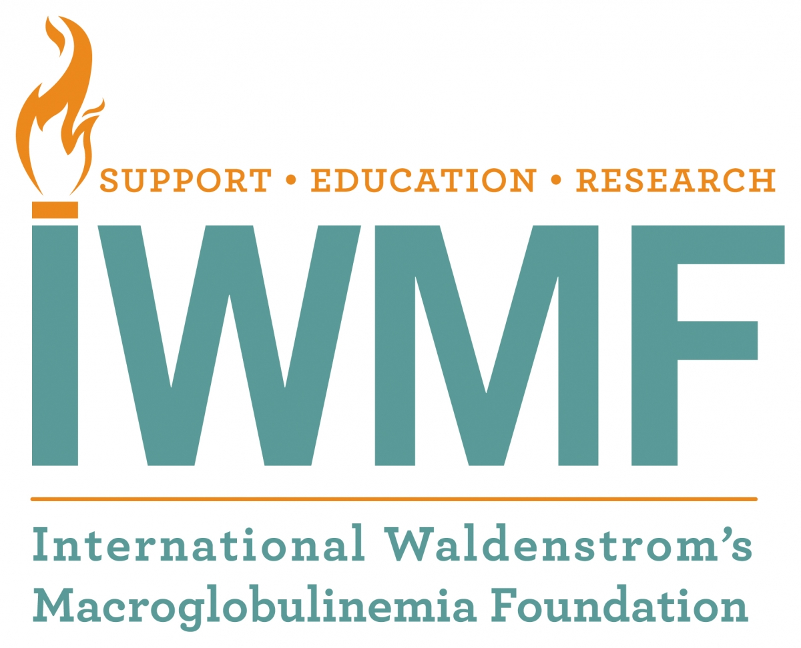

WhiMSICAL Study
Waldenström’s Macroglobulinemia Study Involving CART-WHEEL

a world-first, ethically-approved, comprehensive global database
of patient-derived data about your WM experience

Join WhiMSICAL to “pay it forward” and help WM patients around the world

What is WhiMSICAL?
WhiMSICAL is a global database allowing Waldenström’s Macroglobulinemia (WM) patients like you to contribute WM-related data, helping to advance current knowledge and understanding of your rare disease.

How does it work?
WM patients complete the questionnaire on the www.cart-wheel.org website, covering areas including WM symptoms, test results, treatments and more. The data is analysed by WhiMSICAL researchers, providing us with a better understanding of the variety of forms WM takes, its complications and treatments. Gathered information is stored securely and treated confidentially.

How can I take part?
If you would like to take part, please visit www.cart-wheel.org to register. Once logged in, consent to participate online (“My consent details”) and enter your information. This can be completed in multiple sittings and updated over time.

Your data cannot be utilised for research until your consent has been given.

For more information, visit www.wmozzies.com.au/index.php/whimsical or email whimsical@iwmf.com.

THANK YOU FOR YOUR INVALUABLE HELP!!
Consider it your personal scientific contribution to conquering WM.

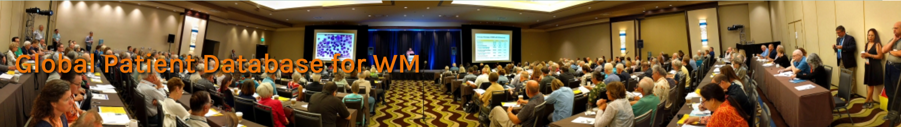
The WhiMSICAL research team, led by researchers in Australia, has presented their findings during a poster presentation at the American Society of Hematology’s annual meeting in December 2017. This is a significant achievement and validation of their efforts thus far, as not all applicants get approved to present at ASH! Congratulations should go out to all WM patients around the world who have participated thus far, as it is our data that made this possible. The poster was subsequently published on the IWMF website and can be found at https://www.iwmf.com/news-and-events/news/global-patient-database-wm
Additionally, IWMF President Carl Harrington and the team presented details and findings at the 3rd annual IWMF-LLS Strategic Research Roadmap Summit meeting. This is the meeting where leading WM researchers from around the world, gather to evaluate and discuss primary focus areas for WM-specific research. Details about the Research Roadmap are at www.iwmf.com/research/research-strategy
While the presentations at both meetings point to the viability of the WhiMSICAL database, there is a CRITICAL need for more patients to participate, and for more data to be entered by participants. With just a few minutes of our time, each of us can make a significant contribution to advance research to develop better treatments and a cure for WM …..and to assist in convincing government agencies to fund treatments for patients! See more details and to participate at www.wmozzies.com.au/index.php/whimsical
As Andrew Warden, the Leader of WMozzies, the IWMF affiliate in Australia, stated recently on IWMF Connect (the IWMF’s online discussion group):
“The WhiMSICAL database is a vital complement to ongoing clinical trials. Both seek to provide strong relevant information needed to arrive at approvals for novel treatment protocols and to convince decision-makers to provide funding for those treatments.”
As Carl Harrington says, “if you want to ‘pay it forward’ and help current and future WM patients around the world, then participate in WhiMSICAL! We all have our disease data. All we have to do is enter it in WhiMSICAL to make a difference for WMers now and in the future.”
See more details about WhiMSICAL and participate now at www.wmozzies.com.au/index.php/whimsical Set aside whatever you’re doing and do it now. Please help us reach 1,000 participating WMers!

