For WMozzies, the IWMF provides:
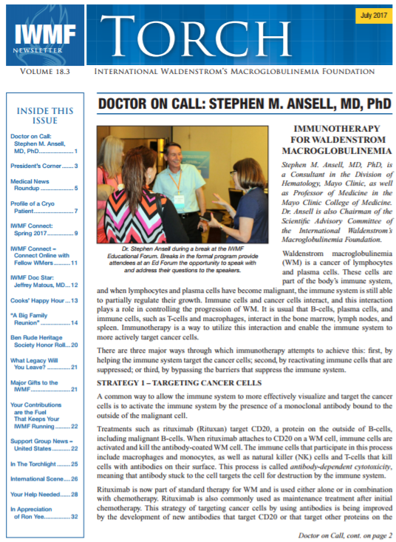

- IWMF Torch quarterly newsletter provides updates on the latest information on WM education, research activities www.iwmf.com/media-library/torch-newsletter
- IWMF Connect, is a friendly Internet-based group discussion forum where you can communicate with others, share experiences and insights, exchange information and get emotional support. Discussions typically focus on WM diagnosis, treatments, side effects, prognosis, related conditions and research
- WM Educational Forums featuring prominent WM physicians and researchers www.iwmf.com/news-and-events/iwmf-educational-forum
- Booklets and Fact Sheets on WM and its treatment www.iwmf.com/media-library/download-iwmf-publications
- Funds Research aimed at ultimately finding a cure for WM. Since 1999, the IWMF has invested over $8.1 million dollars in research on our disease

For WMozzies, Leukaemia Foundation offers:

The Leukaemia Foundation is the only national charity dedicated to helping those with leukaemia, lymphoma, myeloma and related blood disorders survive and then live a better quality of life. The Leukaemia Foundation provides free services and support across Australia. Every person’s experience of living with Waldenström’s Macroglobulinemia is different. It’s not always easy, but you don’t have to do it alone. Please call 1800 620 420 to speak to a support staff member or to find out more about the services the Leukaemia Foundation offers. Alternatively, contact us via email on info@leukaemia.org.au or visit leukaemia.org.au.

Services cover emotional support, blood cancer information, education and support programs, accommodation, transport, advocacy and blood buddies peer support. Each blood services coordinator is qualified and experienced in nursing or allied health. They are highly trained, caring and work closely with other health professionals. The highest level of personalised and practical support is given.

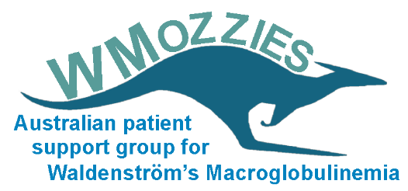
WMozzies helps the Waldenström’s Macroglobulinemia (WM) community in Australia with peer support, advocacy, discussion forums, research and educational information. WMozzies is backed by:
- International Waldenström’s Macroglobulinemia Foundation (IWMF) www.iwmf.com./
- Leukaemia Foundation (LF) www.leukaemia.org.au
To Join WMozzies, please contact WMozzies leader, Andrew Warden, by phone 0408 303 718 or by email andrew.warden@bigpond.com

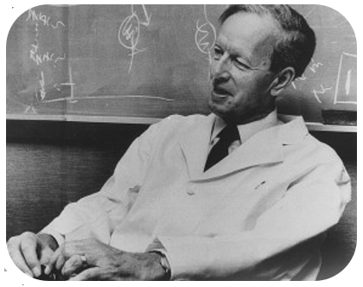
Jan Gösta Waldenström was a Swedish doctor of internal medicine, who in 1944 first described the disease which bears his name, Waldenström's macroglobulinemia

WMozzies provides:
- Website www.wmozzies.com with useful information for patients and carers
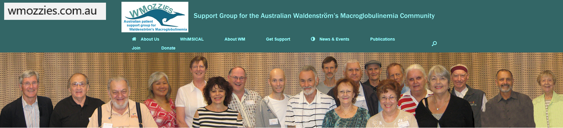

- Participation in Talk List Forum - our online forum sharing information with others in the group and getting other’s experience about living with WM and treatment options
- Access to IWMF services including WM information, publications, education, IWMF Connect online forum and LIFELINE
- Personal support from Leukaemia Foundation covering information, emotional support, education programs, and advocacy

Support to the Newly diagnosed

- A very difficult time for you, your family and your friends
- Experiencing the gamut of different emotions that come with a cancer diagnosis
- There is so much new information to learn
- Where do you begin?
- WMozzies is here to help

Important tips for newly diagnosed
- Take your time to read and absorb the available information
- Come back often to explore available information as you continue your journey with WM.
- Remember that knowledge is power
- The better informed you are, the better your chances for successfully managing your WM and maintaining a good quality of life.

Help for you:
- To learn some basics about WM, sometimes referred to as a lymphoplasmacytic lymphoma (LPL).
- To understand the medical tests and their results which are performed to help diagnose and monitor your disease.
- With website and our publications which are up to date, patient-centred resources
- With members to share their experience of where you are now
- To provide you with the essential tools of support and education
- To help you feel empowered as you begin to understand and live with this rare disease.

Available resources for you
- A comprehensive packet of information (Info Pak) created by the IWMF specifically for the newly diagnosed available online at www.iwmf.com/about-wm/newly-diagnosed
- Most up to date, easy to understand publications on the disease, medical tests, treatment options, second opinions
- Selected introductory videos by experts in WM from Educational Forums.
- List of services to help patients and their caregivers understand and cope with WM
- A network of Support Groups, WMozzies online forum, and telephone support
- A wealth of information about WM
- WM coverage including a description of the disease, causes and risk factors, prognosis, tests to diagnose and monitor the disease, treatments, and types of responses
- Access to helpful tips on talking to your doctor, getting a second opinion, organizing your medical

records, finding clinical trials, and healthful daily habits
- The IWMF Physicians Directory – to help you find an Australian WM Expert for consultation and/or second opinion www.iwmf.com/get-support/directory-wm-physicians

Empowerment for WM patients in WM research

www.wmozzies.com.au/index.php/whimsical/
- WM patients globally contribute their details to the database, and print out their summary for personal use.
- Data entered by / for WM patients contributes to research on our disease.
- The database is designed to address some of the barriers facing effective research into our rare cancer.
- The aim is to gain a better, understanding of WM symptoms and correlation to pathology results, family history and genetics
- The research also covers triggers to commence therapy, different treatments, their efficacy and tolerance
- WhiMSICAL database will provide foundation for hypothesis generation and improving our understanding of this rare disease
- Research findings may identify disparities in treatment access within countries and internationally

